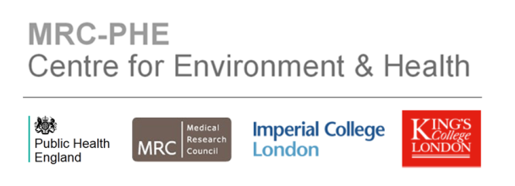

MRC-PHE CENTRE FOR ENVIRONMENT AND HEALTH

INTERNATIONAL SCIENTIFIC ADVISORY BOARD - 2017

MEMBERS

Professor Jonathan Samet – Chair
Director of USC Institute for Global Health
Keck School of Medicine
University of Southern California

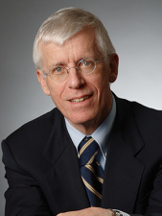
Jonathan M. Samet, a pulmonary physician and epidemiologist, is Professor and Flora L. Thornton Chair for the Department of Preventive Medicine at the Keck School of Medicine. Dr. Samet has investigated diverse health issues using epidemiological approaches. His research has focused on the health risks of inhaled pollutants—particles and ozone in outdoor air and indoor pollutants including secondhand smoke and radon. He has also investigated the occurrence and causes of cancer and respiratory diseases, emphasizing the risks of active and passive smoking. He has served on numerous committees concerned with using scientific evidence for the development of policy to protect public health. For several decades, he has been involved in global health, focused on tobacco control and air pollution. He currently chairs the Clean Air Scientific Advisory Committee of the U.S. EPA and also the FDA’s Tobacco Products Scientific Advisory Committee. He was appointed to the National Cancer Advisory Board in 2011. He was elected to the Institute of Medicine of the National Academy of Sciences in 1997.

Professor Chris Holmes
Professor of Biostatistics in Genomics
Nuffield Department of Clinical Medicine and Department of Statistics
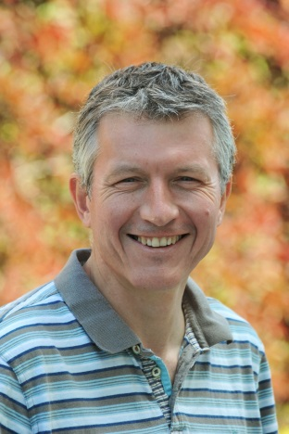
University of Oxford

Chris Holmes has held the position of Professor of Biostatistics in Genomics in the Nuffield Department of Clinical Medicine and the Department of Statistics at the University of Oxford since 2014, a post that carries with it a Fellowship of St Anne’s College Oxford. His research interests are in spatial statistics, Bayesian non-parametrics and statistical problems in genetics. He is one of the co-founders of the Oxford-Man Institute. He was awarded the 2009 Guy Medal in Bronze by the Royal Statistical Society.

Dr Daniel Greenbaum
President and Chief Executive Officer of the Health Effects Institute
Boston, MA 02110-1817

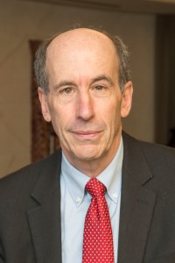
Dan Greenbaum joined HEI as President and Chief Executive Officer in 1994. In that role, He leads HEI’s efforts to provide public and private decision makers with high quality, impartial, and credible science about the health effects of air pollution in order to inform air quality decisions in the developed and developing world.
Greenbaum has been a member of the U.S. National Research Council Board of Environmental Studies and Toxicology and Vice Chair of its Committee for Air Quality Management. He recently served on the NRC’s Committee on The Hidden Costs of Energy and on their Committee on Science for EPA’s Future. He serves as Chair of the Board of the International Council on Clean Transportation, a non-profit organization providing technical analysis and support to the agencies involved in seeking clean vehicles worldwide. In 2010, he received the Thomas W. Zosel Outstanding Individual Achievement Award from the U.S. EPA for his contributions to advancing clean air.

Professor Anne Willis
Director of MRC Toxicology Unit
University of Leicester


Anne Willis has been Professor in Biochemistry at the University of Leicester since 2004. In 2009 she was awarded a BBSRC Professorial Fellowship to research post-transcriptional control of gene expression following exposure of cells to agents that cause genotoxic stress. She is Programme Leader for Post-transcriptional Control of Gene Expression following toxic injury.
Research initiated by the Willis laboratory has identified a new network that regulates translation following exposure of cells to UVB light. In 2010 she was appointed as Director of the MRC Toxicology Unit, which has a remit to deliver field-changing mechanistic insights into toxicology and disease. In January 2017 she was awarded an OBE for services to Biomedical Science and promoting the careers of women in science.

OBSERVERS

Medical Research Council
Dr Tim Cullingford
Programme Manager
Medical Research Council
Public Health Representative
Dr Simon Bouffler
Deputy Director of the Centre for Radiation, Chemical and Environmental Hazards
Public Health England

Public Health Representative
Dr Bernie Hannigan
Research, Translation & Innovation Division
Public Health England

